IMG_256

### **[点微]短信接口**

阿里大于短信接口

**号码归属地限制设置**

**第一步：打开接口申请地址**

[https://market.aliyun.com/products/57126001/cmapi022206.html](https://market.aliyun.com/products/57126001/cmapi022206.html" \t "http://www.tomwx.cn/_blank)

[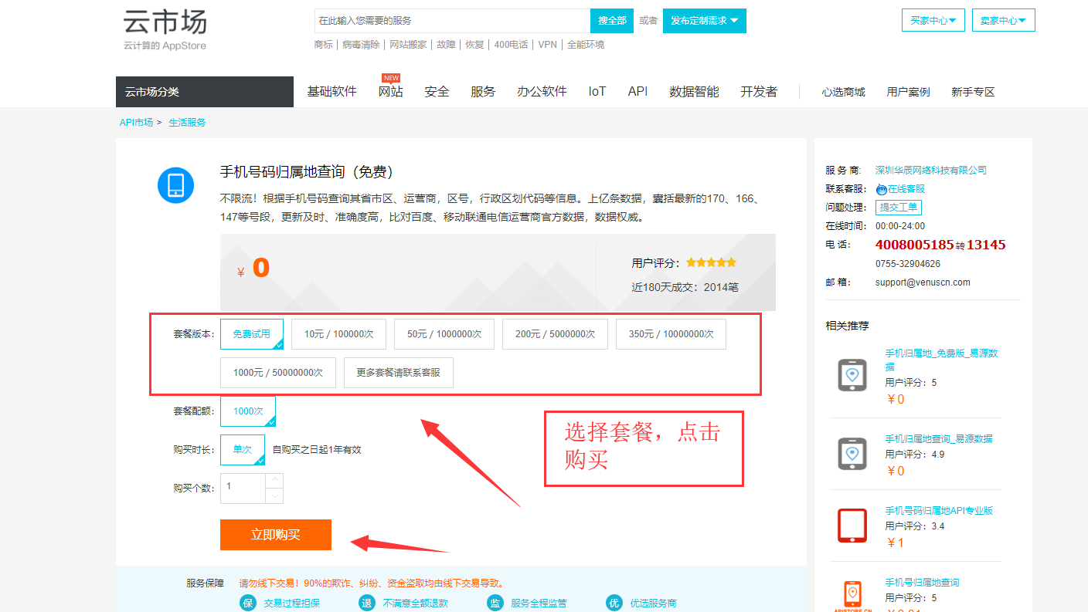](http://www.tomwx.cn/source/plugin/tom_editor/editor/attached/image/20181016/20181016021259_91905.png)

**第二步：复制AppCode 填写到后台总的设置填写**

打开 [https://market.console.aliyun.com/imageconsole/index.htm](https://market.console.aliyun.com/imageconsole/index.htm" \t "http://www.tomwx.cn/_blank)

[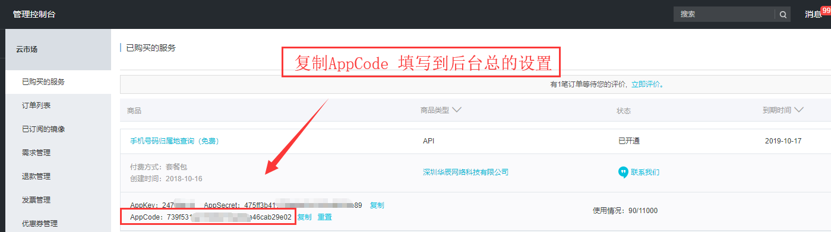](http://www.tomwx.cn/source/plugin/tom_editor/editor/attached/image/20181016/20181016021413_95918.png)

**第三步：设置允许接受短信验证码地区**

**填写地区去掉后面的省市，比如：江苏省就填写江苏、苏州市就填写苏州**

[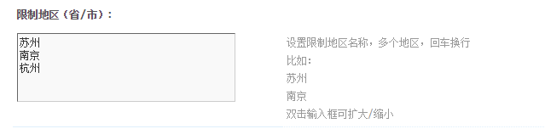](http://www.tomwx.cn/source/plugin/tom_editor/editor/attached/image/20181016/20181016021520_48645.png)